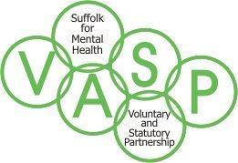

Haverhill Locality VASP
AGENDA

Wednesday 4th April 2018
10.00 am – 12pm
At
Leiston Community Centre, Leiston Road, Haverhill, Suffolk
CB9 8JJ

Minutes: to be confirmed

- Welcome / apologies & brief introductions

- What is VASP and why bring it to Haverhill??

- What’s going on - who/what/where? future events

- Building from here…..

- Time To Change Update/VASP Co-ordinator’s update (10)

- Haverhill Locality concerns (VASP priorities)

- AOB: Mental Health awareness week (14th May - 20th May)

Dates of future meetings tbc

