Suffolk VASP Evaluation March 2020 – a summary of the feedback and how the Suffolk VASP is responding to suggestions… This Evaluation gathered feedback from 108 Suffolk VASP members about their experience of the Suffolk Voluntary and Statutory Partnership (VASP) using an online survey, which was available from 13th February to 1st March 2020. There were then 984 members of the VASP network, which means the survey responses represented a 11% response rate.

Which VASP groups have you visited?
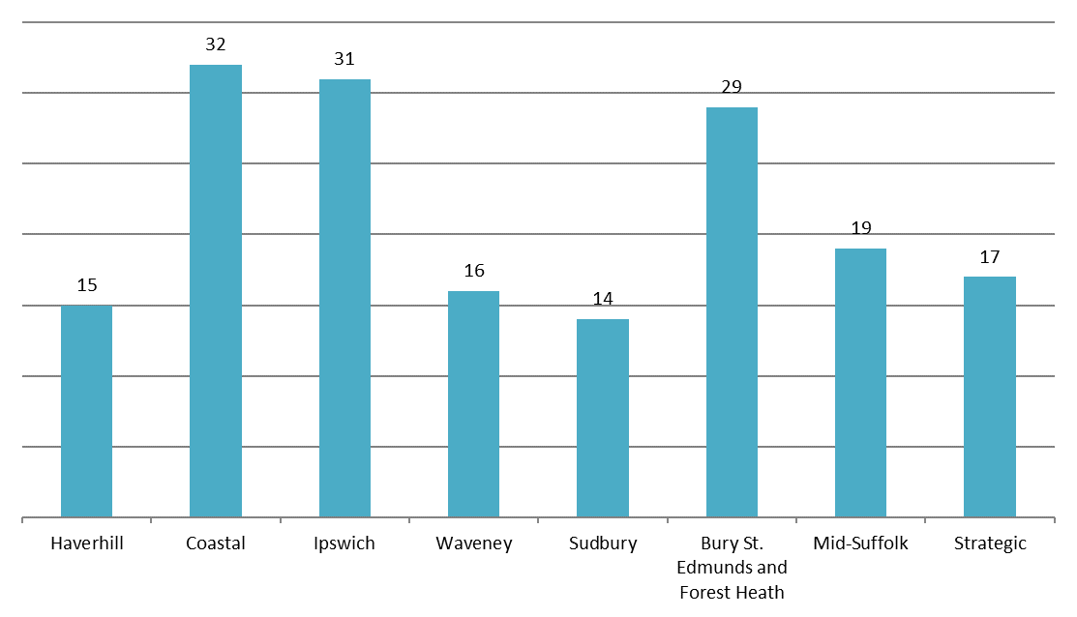
Survey responses came from people who had attended VASP groups across Suffolk, providing a representative sample and good geographical spread.

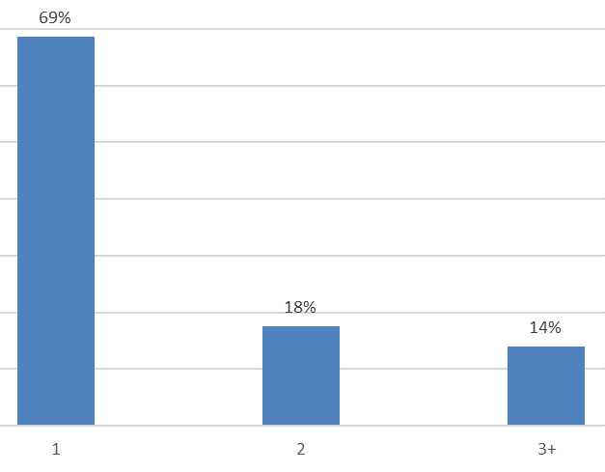
Attending multiple VASP groups
18% of people had attended two different VASP groups, and 14% had attended three or more.

“The Suffolk VASP has shared helpful news relating to mental health and wellbeing”
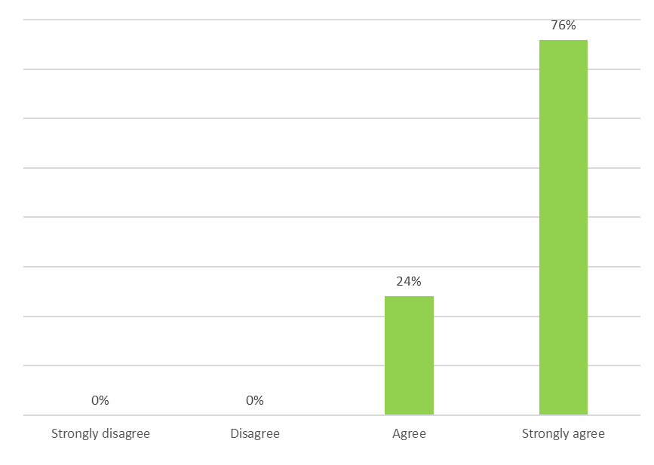
100%
agreed that the VASP shares helpful news about mental health

“From the Suffolk VASP I have usefully learned about a new group or organisation”
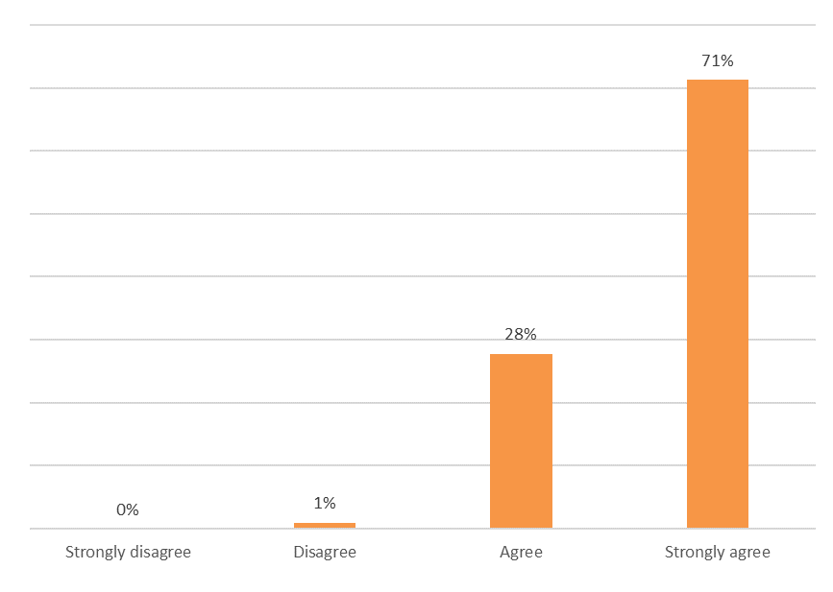
99%
agreed they have learnt useful information about another organisation

“I consider the Suffolk VASP to be providing a valuable service”
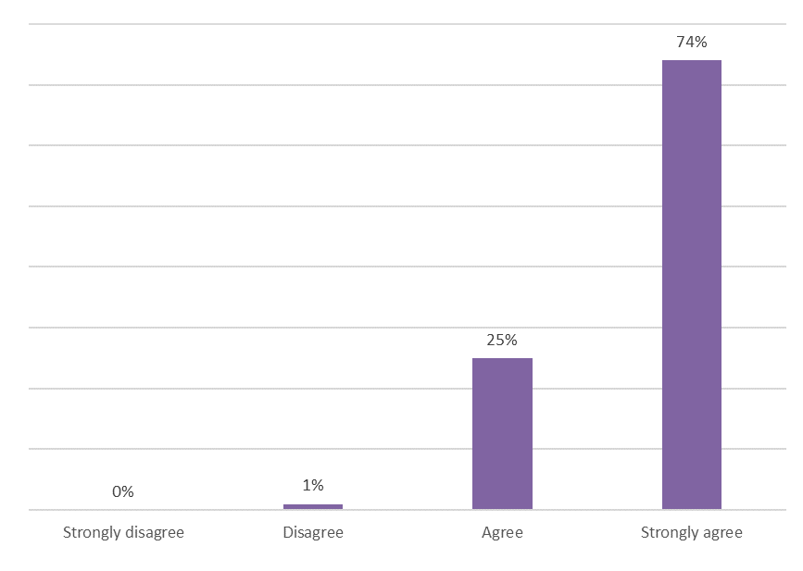
99%
agree the VASP provides a valuable service

The services that participants in this evaluation work within;
People who responded to the survey came from a wide range of organisations and roles, including:

4YP - CEO
Access Community Trust
ActivLives - CEO
Alcoholics Anonymous - Public information and Health liaison
Allsorts Support Services - Company Secretary
Alumah - Founder/CEO
Bury St Edmunds Christians Against Poverty Debt Centre - Debt Centre Manager & Debt Coach
Cancer Research UK - Health Professional Facilitator
Churches Together in Stowmarket - Member of the clergy
CIC Group - Community Coordinator
Citizens Advice - Volunteer adviser
Citizens Advice - Community Connector
Citizens Advice - West Suffolk, Project Manager
Citizens Advice - Case worker
Connect for Health - Community connector
Dementia Together (Sue Ryder) - Dementia Navigator
Disability Advice
DWP - Employer Advisor
DWP - Jobcentre Leader
DWP - Point of contact for vulnerable customers
East Ipswich Mindfulness Group - Facilitator
Employment Services NHS - Employment Specialist
Farming Community Network - Volunteer
Fine Not Fine - Managing Director
Green Light Trust - Head of Partnerships
Green Light Trust - Participant Engagement Co-ordination
Health Service - team leader
Healthwatch Suffolk - Community Development Officer
Hearing Voices group - Member
Heart of the Matter - Owner
Herbaculture - Director
Home Group
Hospice - Team leader
Julian Support
Level Two Youth Project - Principal Youth Worker
Libraries / SAGES partnership
LifeLink - Coordinator
Local Authority
Local Government - Partnerships Manager
Mental health
Mind
Myworkhive - Director
National Careers Service - Careers Advisor
NHS
NHS - Social Worker
Notting Hill Genesis - Service Delivery Manager
NSFT - Governor
NSFT - Community Health Connector
NSFT - Community Mental Health Nurse
NSFT – People Participation Lead
NSFT - Psychologist
OneLife Suffolk
Open Mind - Team Leader
Our Special Friends - CEO
Papworth Trust - Employment Adviser
Police - ISVA
Private Home Care provider - Head of Community Engagement
Psychotherapist - Private practise
Reach Community Projects - Volunteer Advisor
Realise Futures - Community Co-ordinator
Realise Futures - Locality Coordinator Peer Support
Re-engage - Development Officer
Richmond Fellowship - Senior Community Link and Recovery Worker
Samaritans - Volunteer
Social Prescribing, Connect for Health
St Nicholas Hospice - Team leader
Statutory homelessness - Front line
Storehouse Foodbank - Team Leader
Suffolk ACS: Stowmarket INT - Senior Practitioner
Suffolk County Council - Community Development
Suffolk County Council - Co-Chair
Suffolk County Council - CYP County Parenting Coordinator
Suffolk County Council - Engagement Hub
Suffolk Cruse Bereavement Care - Area Coordinator
Suffolk Family Carers - Military Families Lead
Suffolk Family Carers - SAGES Worker
Suffolk Libraries - Library Manager
Suffolk Mind - Allotments service manager
Suffolk Mind - Suffolk Work Well Case Worker
Suffolk Mind - Suffolk Work Well Manager
Suffolk Mind – Artist in Residence
Suffolk User Forum - Engagement lead
Terrence Higgins Trust - Health Promotion Specialist
The ACE Project - Co-founder
The Befriending Scheme
The Cambridge Pringle Group
The Matthew Project - Lead Worker
The Salvation Army - Administrator
The Seckford Foundation - Rural Apprenticeships and Mentoring Manager
The Stone Foundation - CEO
The Village Orchard Norwich - Director of Therapeutic services and Community Resources
Total Voice Suffolk - manager
Walton Parish Nursing - Parish Nurse
Waveney Domestic Violence & Abuse Forum - Coordinator
Well-being for Women
Wellbeing Service- Director
West Suffolk Community Engagement – Volunteer

Please describe one thing that you have found helpful from participating in the Suffolk VASP network;
Sharing a representative selection of the feedback we received within this section. All of the feedback is tremendously useful – thank you to all those who participated:
- Great to hear what other organisations are doing and being able to promote our events and activities.
- Helpful to know what is happening in the area and where I can signpost people.
- It has been very useful to meet people around the table and hear about new initiatives.
- Keeping up to date with the various voluntary groups and what they offer.
- Networking and meeting new groups.
- Getting to know other local organisations all striving for the same outcomes.
- I have found useful information about services and events that I was not previously aware of.
- Newsletters - a useful source of up to date information.
- I have found out about local support groups I have been able to refer people to.
- Regularly having opportunities to connect with people from across lots of different organisations.
- A space to be able to share and learn about helpful groups, organisations and events.
- To be able to signpost customers to the correct person and to be able to have the up to date information to hand.
- Great networking, up to date information, groups which are not able to advertise well due to size, location or resources, are really-well represented through this network.
- Being able to advertise our service, but also finding out about others - equally valuable.
- The Strategic meetings are a good opportunity to keep in touch with what's happening, without being too intensive.
- Contact with a number of local organisations that I would not otherwise have found out about!
- Having the regular emails, containing events and useful information, which is passed onto colleagues and those whom I support.
- The sharing of news, groups and opportunities is wonderful.
- Opportunity to meet representatives of third sector organisations, that I would not otherwise have had contact with, especially as I am relatively new to Suffolk.
- Information and sharing good practice between services.
- So many charities and organisations that I am able to share with my customers and there has been training events that I have attended which I would never have known about it not for Suffolk VASP.
- Sharing what is happening locally and in real time. It’s easy to add projects and events. It’s easy to access with the weekly updates. Great for minority and hard to reach group-projects to have a platform
- Learning about organisations, particularly from guest speakers such as Wednesday's Child and the County Lines information
- Learning about so many other organisations that deliver services I am able to signpost our referrals to or work with to jointly support.
- They give people the opportunity to forge new relationships with others and network/share information

Do you have any further feedback about the VASP?

Responses which gave positive feedback
Excellent service and the provision of networking opportunities
It's great - keep it up...
I don't attend any of your meetings but colleagues who do share your emails with our Team.
Do not make it to many groups so appreciate the email updates.
I haven’t attended a meeting yet, but the email newsletters are wonderful! Full of extremely useful information.
I find the VASP a really valuable group to attend.
Very useful information provided
Please continue your good work.
This is an amazing service, long may it continue.
I find the group a valuable link in the area and can better understand the services available with a view to supporting our service users.
Succinctly organised. Relevant guests. Good information share.
I have always found the VASP to be an excellent source of very valuable information, a brilliant way to meet and hear about other organisations in the area and a great way to impart information about own organisation's services.
We find the information that is emailed to us is valuable for us to keep up to date with what is happening the areas that we cover.
Find the e-bulletins extremely helpful to find out what other orgs/groups are doing, which helps us signpost our clients.
I find the newsletters very useful in my work within DWP to share with my colleagues and customers some of the extra services and support available.
Networking in this way is invaluable in supporting some of the most vulnerable people in our communities, those with complex needs require multiple organisations to support them and VASP provides a unique opportunity for several organisations to work together towards a common goal.
Simon's regular VASP round-up Emails I find to be such a useful resource to help me know what extra things are going on in the county.
Great way to help shape a resourceful compassionate community! Keep up the good work! Thank you!
Excellent source of information and collaborative working.
Very useful information sharing, thank you.
Working across two counties I realise just what an asset the VASPs are in Suffolk. Norfolk would benefit from this kind of informal collaboration.
Invaluable network for Suffolk.
Found it all very interesting on both work related support and personal aspect and even booked myself onto one of the events that Suffolk Mind are running.
Communication … is excellent. I hear about things I wouldn't otherwise know about and can pass on to service users.
Been attending for years. Always proven to be useful.
The emails are really helpful to recognise the support that is available in the local community, particularly with helping service users to get involved in getting their voice heard.
All those involved provide an outstanding, valuable and much-appreciated service
Thank you for all your work in coordinating the VASP and for your emails - it is very much appreciated.
This is a great partnership and way to share information.
A really great service that I look forward to receiving information about each week and have been able to share my project with a wide range of people…
You are providing a really important resource by increasing the communication between all the services, thank you for helping us to keep in the loop.
I have been on and off involved since the beginning of the group and find it an important service to get information about what services and the changes in services specific to the area and the client base we support.
The newsletters are great at sharing information.
A great opportunity to promote my role/service and to find out about others. Keep up the good work!
Keep it going in the designated areas.
Keep up the good work!
It's a valuable forum. Clergy and others within the church are from time to time involved in supporting people with mental health problems. I act as an informal channel of communication - both ways

Responses that were sharing a suggestion or an idea… and importantly how the Suffolk VASP is responding…

Feedback; Something simple, but I just wonder if the name is helpful?
Response; Some people are puzzled by the word VASP… what’s a VASP? So, we’re aiming to spell out in our communications that VASP stands for Voluntary and Statutory Partnership. It’s been called this since the network began nearly 20 years ago and so we don’t think it would be fair or best to change the name.

Feedback; Could the newsletter be presented in a different way which makes it easier at a glance?
Response; The Suffolk VASP is now sharing the newsletter in a different way, through Mailchimp we have gained access to their templates and tools for newsletters. We hope people are finding the new format easier to navigate and yet just as colourful!

Feedback; In any Locality, if we think there could be a beneficial change within our meetings (each Locality group chooses when, where and how often, they wish to meet) how do we influence the group, the Chair, to bring about changes...
Response; The chair or co-chairs for each Locality VASP group are listed on the Suffolk VASP website and in each news sharing e-mail message. In the first instance please get in touch with the local chair(s). Please do bear in mind our Locality chairs volunteer for the role, it’s brilliant of them to do this and they deserve always to receive kind polite communication. Anyone is welcome to contact the Suffolk VASP’s co-ordinator… simon.king@healthwatchsuffolk.co.uk or the Chair for the Strategic VASP, who also chairs for the VASP chairs group… gill.jones@healthwatchsuffolk.co.uk. The VASP’s chairs and co-chairs have the opportunity to meet quarterly, before each Strategic VASP meeting.

Feedback; I find my Locality meeting seems to include the same sorts of info from the same groups and services.
Response; Every VASP meeting has an open door, no one need send apologies or indeed commit to attending in advance (unless you happen to be a Speaker and then we really appreciate you attending!). Who attends is self-selecting. In 2019/20 we started to list all the forthcoming Locality VASP meetings, date/time/place in the news sharing messages to help inform/encourage as many people as possible to join in. People can also visit any of the Locality VASP meetings, so someone may choose to dip their toe into a new Locality meeting and see what happens there. Through people coming along and sharing their news, we have very useful meetings and around the whole county.

Feedback; The communication is really good, however there are rarely events that are held in our local town. Therefore, none of our service users have been able to engage with them, even though the topics would be relevant. Events closer to home would be very useful. Thank you
Response; Please talk with your nearest Locality VASP chair. Locality VASP groups do arrange local community engagement events and activities, then members of the group get together and have an information sharing event/fair to talk together with people in a local town/community. Each Locality VASP group has a (modest) budget each year, which they can use to help enable community engagement to happen, for example to hire a hall/venue and/or to pay for refreshments.

Feedback; In time the VASP network should focus on outcomes and help to shape possibilities in addition to its core networking role.
Response; The Suffolk VASP has a clear aim, to help enable the sharing of information and to help bring people together, to bring services together, all for the purpose of helping people in their communities, countywide, with their mental health and wellbeing by helping people to know what support is available. We think it’s important to stay focussed on this aim, through enabling people to share information we think there are times when the VASP may well influence decision makers, but we don’t set out with an agenda regarding what we think others should do, that would be a significant departure from the VASP’s long established role.

Feedback; Great organisation needs more funding.

Response; The Suffolk VASP is very fortunate to be receiving sufficient funding each year to pay for; one part time co-ordinator (the only paid role), and to allow each Locality VASP to have an events budget and to pay for costs such as printing. The Locality Group chairs volunteer for the role (stars that they are). Healthwatch Suffolk very valuably host the Suffolk VASP, and in return for a modest fee of £50 per month, Healthwatch Suffolk provide for the support that the network needs; financial, administration, office space and supervision. Like any service the Suffolk VASP needs some funding to meet running costs but the VASP is not looking to expand for the sake of being bigger, this is happening naturally and if it should need more funding in the future it will be because the network is growing, and for information sharing and networking to be thriving between services, especially between the voluntary and sectors is surely a wonderful thing.

Feedback; We would like our information shared
Response; Please send information for sharing to the Suffolk VASP co-ordinator, simon.king@healthwatchsuffolk.co.uk, and if the information relates to one or more Locality areas then please also send to those VASP Locality groups chair(s).

Feedback; Maybe we could provide an outdoor venue for a meeting…
Response; We like the idea of Locality VASP groups being invited to have their meeting in a different and interesting setting, perhaps one where art or gardening activities take place… in this instance in a bus! We shall follow up with the organisation making this suggestion. Any organisation can contact their local VASP chair and make a suggestion... the Coastal Locality VASP had a meeting in The Hut on Felixstowe seafront last year at the water’s edge… The Locality VASP group chairs are always open to ideas

Feedback; It’s a shame that some health professionals that were involved are no longer able to attend due to their remits changing, and their employers not feeling it important enough to allow the staff to continue.
Response; Yes, especially if people would like time to attend their Locality VASP group meeting and aren’t allowed the time. The Suffolk VASP, especially between all our chairs, has pretty good contacts and reach across lots of groups and services. If anyone is struggling to participate because they aren’t allowed the time welcome to let the Suffolk VASP co-ordinator know and perhaps, maybe, we can help.

Feedback; I still hope for one list/register of all the mental health services available in my local town. When sad, anxious, desperate people come to the Drop-in, I still find it difficult to know where to signpost them.
Response; The wish to have a comprehensive list of local services, what they offer, there access criteria and contact details, is shared by people and services countywide, especially by those who are signposting. It’s not uncommon for such lists to be drawn up, and sometimes we find through the VASP network we find this is happening by more than one person/service within the same area at the same time… The challenge for everyone is the pace at which services and what they offer change, not unusually because funding has either ended or expectations in return for funding have altered. Almost inevitably any cataloguing exercise then contains out of date information very quickly indeed.

Feedback; It feels very Ipswich centric.
Response; We’re sorry if anyone feels the VASP has a focus upon Ipswich, or favours sharing information about services in Ipswich (or on any other single town/part of the county), truly the Suffolk VASP is for the whole county.

Feedback; Would love some more information regarding Norfolk service for young people.
Response; People have asked if there is an equivalent to the Suffolk VASP in Norfolk. We’ll gladly share our learning and approach with anyone choosing to launch in Norfolk. We were poised to support a first exploratory meeting for a Gt. Yarmouth VASP when Covid19 struck. Assuming this goes ahead in the future, it could be the very first step in establishing a new network for Norfolk, to which the Suffolk VASP will gladly be a helpful friend.

Feedback; Slight feeling of concern that representatives of statutory bodies form the bulk of the attendees.
Response; It varies between Localities and meetings, it can happen that there are far more people from statutory services, or from voluntary services, but we believe it’s very rare not to have both sectors ‘represented’ in any Locality VASP meeting. The whole VASP network (now well over 1,000 people) includes a very diverse range of groups and services. The list included in this report is an indication of this range, and the list shows just the people (11% of the network) who took part in this evaluation.

In conclusion… Thank you to everyone who participated in this Evaluation. The Suffolk VASP is something special. As the co-ordinator for the Suffolk VASP I feel a strong sense of responsibility to care for the network, which hugely benefits from the goodwill of the Locality VASP chairs and the positive ways in which lots of people participate across all the Locality groups.

Simon King – Suffolk VASP co-ordinator … e-mail; simon.king@healthwatchsuffolk.co.uk
and
Gill Jones – Chair for Strategic VASP

